Take Notes
- Adjust course manager video 3
  - Amend script!
- Add note to description field, credit hours, course abbreviation
  - “This is standard text imported from SIS, please don’t touch”
  - Will overwrite edited information in courses
Introduction to course creation foundations in Drupal. Repeatable to a maximum of 9 cr hrs or 3 completions. This course is graded S/U.

Course overview
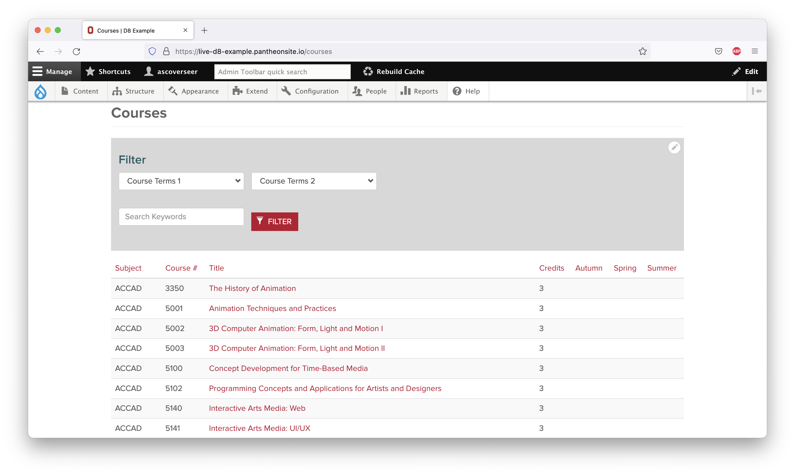
Lorem ipsum dolor sit amet, consectetur adipiscing elit, sed do eiusmod tempor incididunt ut labore et dolore magna aliqua. Quisque non tellus orci ac auctor augue mauris. Leo duis ut diam quam nulla porttitor massa id. Sit amet porttitor eget dolor.
Et ultrices neque ornare aenean euismod elementum nisi quis eleifend. Amet volutpat consequat mauris nunc. Duis ultricies lacus sed turpis tincidunt id aliquet risus feugiat.
Ac placerat vestibulum lectus mauris ultrices eros in cursus turpis.
Varius sit amet mattis vulputate enim. Amet mattis vulputate enim nulla aliquet. Suspendisse in est ante in nibh mauris cursus mattis molestie.
Faucibus purus in massa tempor nec:
- Accumsan sit amet nulla facilisi morbi tempus iaculis urna id
- Duis convallis convallis tellus id interdum velit laoreet id
- Urna id volutpat lacus laoreet non curabitur gravida arcu
Ullamcorper malesuada proin libero nunc consequat. Commodo odio aenean sed adipiscing diam donec adipiscing tristique risus.

